

Instruction Manual

Circular Saw
Model :FSC2000
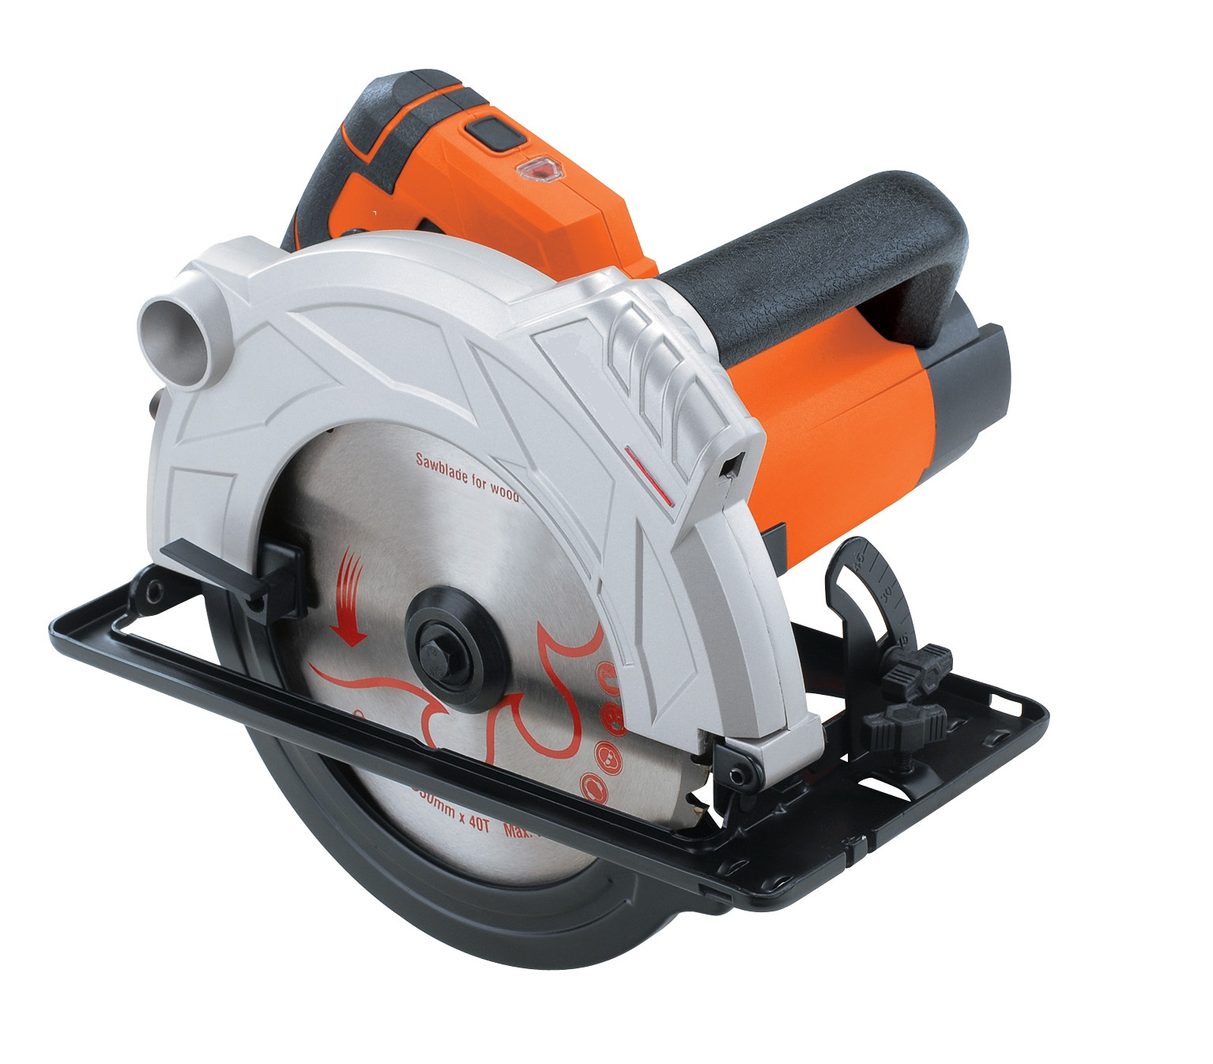

BJ2011
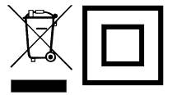

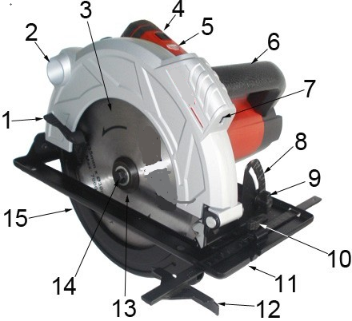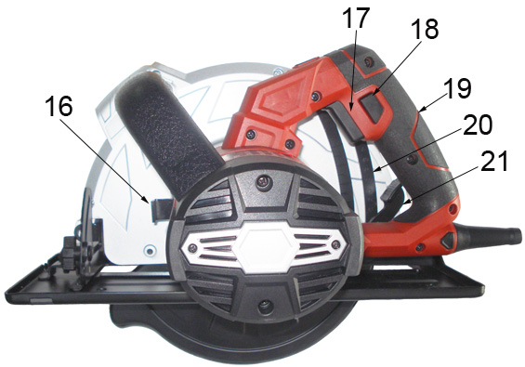
Fig. 1 Fig. 2
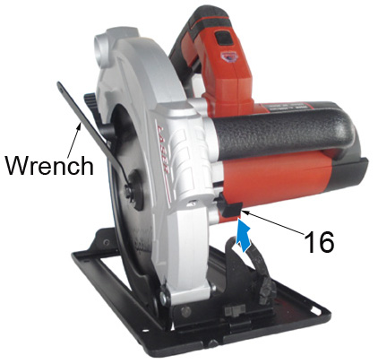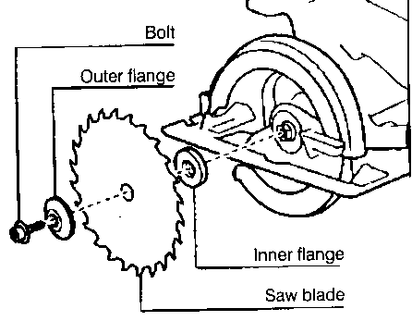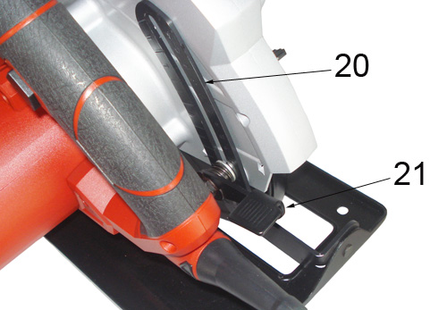
Fig. 3 Fig. 4 Fig. 5

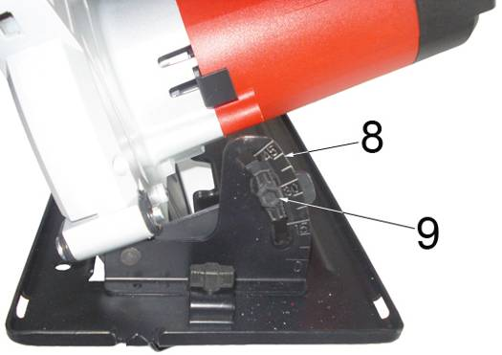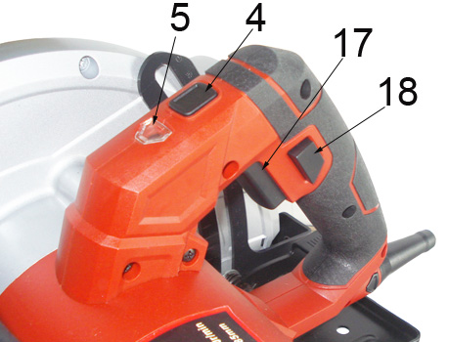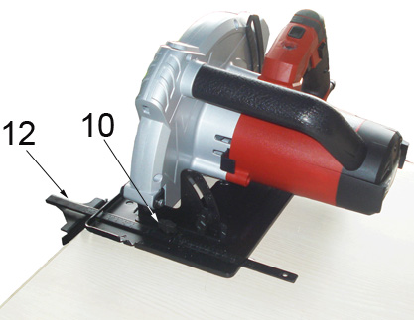
Fig. 6 Fig.7 Fig. 8

General Power Tool Safety Warnings
WARNING：Read all safety warnings and all instructions. Failure to follow the warnings and instructions may result in electric shock, fire and/or serious injury.
Save all warnings and instructions for future reference.
The term "power tool" in the warnings refers to your mains-operated (corded) power tool or battery-operated (cordless) power tool.
1) Work area safety
a) Keep work area clean and well lit. Cluttered or dark areas invite accidents.
b) Do not operate power tools in explosive atmospheres, such as in the presence of flammable liquids, gases or dust. Power tools create sparks which may ignite the dust or fumes.
c) Keep children and bystanders away while operating a power tool. Distractions can cause you to lose control.
2) Electrical safety
a) Power tool plugs must match the outlet. Never modify the plug in any way. Do not use any adapter plugs with earthed (grounded) power tools. Unmodified plugs and matching outlets will reduce risk of electric shock.
b) Avoid body contact with earthed or grounded surfaces, such as pipes, radiators, ranges and refrigerators. There is an increased risk of electric shock if your body is earthed or grounded.
c) Do not expose power tools to rain or wet conditions. Water entering a power tool will increase the risk of electric shock.
d) Do not abuse the cord. Never use the cord for carrying, pulling or unplugging the power tool. Keep cord away from heat, oil, sharp edges or moving parts. Damaged or entangled cords increase the risk of electric shock.
e) When operating a power tool outdoors, use an extension cord suitable for outdoor use. Use of a cord suitable for outdoor use reduces the risk of electric shock.
f) If operating a power tool in a damp location is unavoidable, use a residual current device (RCD) protected supply. Use of an RCD reduces the risk of electric shock.
NOTE：The term residual current device (RCD) may be replaced by the term ground fault circuit
interrupter (GFCI) or earth leakage circuit breaker (ELCB).
3) Personal safety
a) Stay alert, watch what you are doing and use common sense when operating a power tool. Do not use a power tool while you are tired or under the influence of drugs, alcohol or medication. A moment of inattention while operating power tools may result in serious personal injury.
b) Use personal protective equipment. Always wear eye protection. Protective equipment such as dust mask, non-skid safety shoes, hard hat, or hearing protection used for appropriate conditions will reduce personal injuries.
c) Prevent unintentional starting. Ensure the switch is in the off-position before connecting to power source and/or battery pack, picking up or carrying the tool.
Carrying power tools with your finger on the switch or energizing power tools that have the switch on invites accidents.
d) Remove any adjusting key or wrench before turning the power tool on. A wrench or a key left attached to a rotating part of the power tool may result in personal injury.
e) Do not overreach. Keep proper footing and balance at all times. This enables better control of the power tool in unexpected situations.
f) Dress properly. Do not wear loose clothing or jewellery. Keep your hair, clothing and gloves away from moving parts. Loose clothes, jewellery or long hair can be caught in moving parts.
g) If devices are provided for the connection of dust extraction and collection facilities, ensure these are connected and properly used. Use of dust collection can reduce dust-related hazards.
4) Power tool use and care
a) Do not force the power tool. Use the correct power tool for your application. The correct power tool will do the job better and safer at the rate for which it was designed.
b) Do not use the power tool if the switch does not turn it on and off. Any power tool that cannot be controlled with the switch is dangerous and must be repaired.
c) Disconnect the plug from the power source and/or the battery pack from the power tool before making any adjustments, changing accessories, or storing power tools. Such preventive safety measures reduce the risk of starting the power tool accidentally.
d) Store idle power tools out of the reach of children and do not allow persons unfamiliar with the power tool or these instructions to operate the power tool. Power tools are dangerous in the hands of untrained users.
e) Maintain power tools. Check for misalignment or binding of moving parts, breakage of parts and any other condition that may affect the power tools operation. If damaged, have the power tool repaired before use. Many accidents are caused by poorly maintained power tools.
f) Keep cutting tools sharp and clean. Properly maintained cutting tools with sharp cutting edges are less likely to bind and are easier to control.
g) Use the power tool, accessories and tool bits etc. in accordance with these instructions, taking into account the working conditions and the work to be performed. Use of the power tool for operations different from those intended could result in a hazardous situation.
5) Service
Have your power tool serviced by a qualified repair person using only identical replacement parts. This will ensure that the safety of the power tool is maintained.
SPECIFIC SAFETY RULES
DANGER:
a) Keep hands away from cutting area and blade. Keep your second hand on auxiliary handle or motor housing. If both hands are holding the saw, they cannot be cut by the blade.
b) Do not reach underneath the workpiece. The guard cannot protect you from the blade below the workpiece.
c) Adjust the cutting depth to the thickness of the workpiece. Less than a full tooth of the blade teeth should be visible below the workpiece.
d) Never hold piece being cut in your hands or across your leg. Secure the workpiece to a stable platform. It is important to support the work properly to minimize body exposure, blade binding, or loss of control.
e) Hold power tool by insulated gripping surfaces when performing an operation where the cutting tool may contact hidden wiring or its own cord. Contact with a “live” wire will also make exposed metal parts of the power tool “live” and shock the operator.
f) When ripping always use a rip fence or straight edge guide. This improves the accuracy of cut and reduces the chance of blade binding.
g) Always use blades with correct size and shape (diamond versus round) of arbor holes. Blades that do not match the mounting hardware of the saw will run eccentrically, causing loss of control.
h) Never use damaged or incorrect blade washers or bolt. The blade washers and bolt were specially designed for your saw, for optimum performance and safety of operation.
Special safety regulations
Causes and operator prevention of kickback:
- Kickback is a sudden reaction to a pinched, bound or misaligned saw blade, causing an uncontrolled saw to lift up and out of the workpiece toward the operator;
- When the blade is pinched or bound tightly by the kerf closing down, the blade stalls and the motor reaction drives the unit rapidly back toward the operator;
- If the blade becomes twisted or misaligned in the cut, the teeth at the back edge of the blade can dig into the top surface of the wood causing the blade to climb out of the kerf and jump back toward the operator.
Kickback is the result of saw misuse and/or in correct operating procedures or conditions and can be avoided by taking proper precautions as given below.
- Maintain a firm grip with both hands on the saw and position your arms to resist kickback forces. Position your body to either side of the blade, but not in line with the blade. Kick back could cause the saw to jump backwards, but kickback forces can be controlled by the operator, if proper precautions are taken.
- When blade is binding, or when interrupting a cut for any reason, release the trigger and hold the saw motionless in the material until the blade comes to a complete stop. Never attempt to remove the saw from the work or pull the saw backward while the blade is in motion or kickback may occur. Investigate and take corrective actions to eliminate the cause of blade binding.
- When restarting a saw in the workpiece, center the saw blade in the kerf and check that saw teeth are not engaged into the material. If saw blade is binding, it may walk up or kickback from the workpiece as the saw is restarted.
- Support large panels to minimize the risk of blade pinching and kickback. Large panels tend to sag under their own weight. Supports must be placed under the panel on both sides, near the line of cut and near the edge of the panel.
- Do not use dull or damaged blades. Unsharpened or improperly set blades produce narrow kerf causing excessive friction, blade binding and kickback.
- Blade depth and bevel adjusting locking levers must be tight and secure before making cut. If blade adjustment shifts while cutting, it may cause binding and kickback.
- Use extra caution when making a “plunge cut” into existing walls or other blind areas. The protruding blade may cut objects that can cause kickback.
Inner pendulum guard
- Check lower guard for proper closing before each use. Do not operate the saw if lower guard does not move freely and close instantly. Never clamp or tie the lower guard into the open position. If saw is accidentally dropped, lower guard may be bent. Raise the lower guard with the retracting handle and make sure it moves freely and does not touch the blade or any other part, in all angles and depths of cut.
- Check the operation of the lower guard spring. If the guard and the spring are not operating properly, they must be serviced before use. Lower guard may operate sluggishly due to damaged parts, gummy deposits, or a build-up of debris.
- Lower guard may be retracted manually only for special cuts such as “plunge cuts” and “compound cuts.” Raise lower guard by retracting handle and as soon as blade enters the material, the lower guard must be released. For all other sawing, the lower guard should operate automatically.
- Always observe that the lower guard is covering the blade before placing saw down on bench or floor. An unprotected, coasting blade will cause the saw to walk backwards, cutting whatever is in its path. Be aware of the time it takes for the blade to stop after switch is released.
Explanation of symbols
 | Conforms to relevant safety standards
 | To reduce the risk of injury, the user must read and understand this manual before using this product.
 | Wear ear protectors. Exposure to noise can cause hearing loss.
 | Wear eye protection.
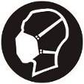 | Wear respiratory protection.
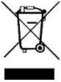 | Do not dispose of old appliances with domestic rubbish
 | Double insulation

SAVE THIS INSTRUCTIONS
Technical Specification:

Model |  | 76502
Rated voltage /frequency |  | 220-240V 50/60HZ
Rated power (W) |  | 2000
No load speed (r/min) |  | 5000
Dia. of sawblade (mm) |  | 235
Max.cutting depth (mm) | 85 | 73
Max.cutting depth (mm) | 56 | 49
Standard accessories |  | wrench --1pc parallel guide--1pc Wood-cutting saw

Functional Description (Fig. 1&2 )
1. Lever of lower guard
2. Dust extraction outlet
3. Saw blade
4. Laser generator switch
5. Power-on indicator
6. Auxiliary handle
7. Laser generator
8. Miter scale
9. Lock knob for angle adjustment
10. Lock knob for parallel guide
11. Baseplate
12. Parallel guide
13. Outer flange
14. Blade clamp bolt
15. Lower guard
16. Spindle lock button
17. ON/OFF switch
18. Lock-off button
19.Main handle
20. Depth of cut scale
21.Lock lever for depth adjustment

ASSEMBLY

Important: Prior to any assembly and adjustment always unplug the tool.
Changing the blade (Fig. 1&3&4)
Warning: Always disconnect the plug from the power mains before making any adjustment or attaching any accessories.
- Place this circular saw on its side on a flat surface. Advice you bring the base plate down as a minimum depth cut then it is ease to change the blade.
- Push the spindle lock button (16) toward motor housing as the arrow shows in fig. 3 and firmly hold it.
- Turn the blade clamp bolt (14) anti-clockwise by using the wrench that supplied with the tool.
- Remove the blade clamp bolt (14)and outer flange (13).
- Raise the lower guard (15) by using the lever for lower guard (1), and then remove the saw blade.
- Clean the saw blade flanges, then mount the new saw blade onto the output spindle and against the inner flange.
- Make sure the saw teeth and arrow on the blade is to be the same direction as the arrow on the lower guard.
- Reinstall the outer flange, and tighten the blade clamp bolt.
- Make sure that the saw blade runs freely by turning the blade by hand.
Depth adjustment (Fig. 5)
- Loosen the lock lever for depth adjustment (21).
- Hold the baseplate flat against the edge of the work piece and lift the body of the saw until the blade is at the right depth determined by the depth of cut scale (20) (align the scale line).
- Tighten the lock lever for depth adjustment.
Angle adjustment (Fig. 6)
- Loosen the Lock knob for angle adjustment (9).
- Adjust the shoe to the desired angle between 0°to 45°. [See miter scale (8)].
- Tighten the lock knob for angle adjustment.
Switching on and off(Fig.7)
Before engage the ON/OFF switch, check that the saw blade is properly fitted and run smoothly, the blade clamp bolt is well tightened.
- Connect the plug to the power supply，the power-on indicator (5) is illumed until the tool disconnect from the power mains.
- To switch on the circular saw, press the lock-off button (18) and pull the ON/OFF switch trigger (17).
- When you release the switch trigger (17), the tool turns off.
Parallel cut adjustment(Fig.8)
- Loosen the lock knob of edge guide (10).
- Slide the parallel guide (12) through the slots in the shoe to the desired width.
- Tighten the lock bolt to fit it in the position.
- Ensure that the edge guide rests against the wood along its entire length to give a consistent parallel cuts.

Laser line generator( Fig. 7),

Warnings: Do not stare directly at the laser beam, do not deliberately aim the beam at personnel and ensure that it is not directed towards the eye of a person for longer than 0.25s.
When you make the line of the cut on the work piece, the laser line generator can help you get better alignment.
Turn on: Press the laser generator switch (4), the laser generator (7) works.
Turn off: Press the switch again.
- Make sure line of the cut on the work piece.
- Adjust the angle of cut as required
- Plug in the machine and start the motor
- When the blade is at its maximum speed (approximately 2 seconds), place the saw on the work-piece.
- Switch on the laser generator from the laser aperture using the laser generator switch (4).
- Align the beam with the mark on the work-piece and slowly push the saw forward using both hands, keeping the red light beam on the mark.
- Switch off the laser beam when completion of the cut.
OPERATION
General cutting
- When starting, always hold the saw handle with one hand and the auxiliary handle (6) with the other hand. Never force the saw but maintain a light and continuous pressure after completing the cut allow the saw to come to a complete stop. When cutting is interrupted, resume cutting by allowing the blade to reach full speed and then reentering the cut slowly.
- When cutting across the grain, the fibers of the wood have a tendency to lift and tear, moving the saw slowly minimizes this effect.
Pocket cutting
1. Disconnect the plug from the power supply before making any adjustments. Set the depth adjustment based on the thickness of the line drawing for the cut .raise the lower guard by using the lift lever.
2. With the blade barely above the material to be cut, start the saw and allow the blade to come to full speed. Gradually lower the blade unto the material to be cut using the front end of the shoe as a pivot point. When the blade starts cutting, release the lower guard. When the shoe is resting flat on the surface being cut, proceed cutting in a forward direction to the end of the cut. Allow the blade to come to a full stop before removing it from the cut. Never pull the saw backward since the blade will climb out of the cut and kickback will occur. Turn the saw around and finish the cut in a normal manner, sawing forward. Use a jigsaw or a hand saw to finish the cut in the corners, if required.
Cutting Large Sheets
- Large sheet or boards require support to prevent bends or sags. If you attempt to cut without leveling and properly supporting the work piece, the blade will tend to bind, causing kickback.
- Support the panel or board close to the cut. Be sure to set the blade adjustment so that you can cut through the material without cutting into the table or workbench. Suggestion: use two by fours to support the board or panel to be cut. If the piece is too large for the workbench, use the floor with the two-by fours supporting the wood.
Maintenance
  - To prevent accidents, always unplug the saw from the power source before cleaning or performing any maintenance the saw may be cleaned most effectively using compressed air. Always wear safety goggles when using compressed air. If compressed air is not available, use a brush to remove dust and chips from the saw.
  - Motor ventilation vents and switch levers must be kept clean and free of foreign matter. Do not attempt to clean by inserting pointed objects through openings.
  - Never use any caustic agents to clean plastic parts. Such as: gasoline, carbon tetrachloride, chlorinated cleaning solvents, ammonia and household cleaners containing ammonia. Do not use any of these to clean the saw.
  - Have an authorized service center examine and/or replace the worn carbon brushes in the event of excessive parking.
  - Blades become dull even when cutting regular lumber, a sure sign of a dull blade is the need to force the saw forward instead of guiding it while making a cut. Take the blade to a service center for sharpening.
  - Keep the machine clean all the time.
  - If you discover any damage, consult the exploded drawing and parts list to determine exactly which replacement part you need to order from our customer service department.
  - Clean the housing only with a damp cloth. Do not use any solvents! Dry thoroughly afterwards .In order to maintain battery capacity ,we recommend the battery to be completely discharged every one month and fully recharged again .Only store with a fully charged battery and top-up the charge from time to time if stored for a long time. Store in a dry and frost-free place, the ambient temperature should not exceed 40°C.
  - If the supply cord of this power tool is damaged, it must be replaced by a similar cord available through the service organization or a qualified authoritative technician.
  - For safety reasons, the machine automatically switches off if the carbon brushes are so worn out that they no longer have contact with the motor. In that case, the carbon brushes must be replaced by a pair similar carbon brush available through the after-sales service organization or qualified professional person.
CAUTION: The brushes must always be replaced in pairs.
CAUTION: Always disconnect the machine from the power supply before removing any electrical covers.
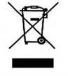
Recycling

Meaning of crossed –out wheeled dustbin:
Do not dispose of electrical appliances as unsorted municipal waste, use separate collection facilities. Contact you local government for information regarding the collection systems available. If electrical appliances are disposed of in landfills or dumps, hazardous substances can leak into the groundwater and get into the food chain, damaging your health and well-being.

